**Mini Project Report on**



**FACE RECOGNITION SYSTEM**



**Submitted in partial fulfillment of the requirement for the award of the degree of**

**BACHELOR OF TECHNOLOGY**

**IN**

**COMPUTER SCIENCE & ENGINEERING**

**Submitted by:**

**RUUDRA AMOLA**  **Univ Roll No: 2016972**

***Under the Mentorship of***

**Mr. Saurabh Kumar Mishra**

**Assistant Professor (CSE)**



**Department of Computer Science and Engineering**

**Graphic Era (Deemed to be University)**

**Dehradun, Uttarakhand**

**January 2023**



**CANDIDATE’S DECLARATION**

I hereby certify that the work which is being presented in the project report entitled

**“Face Recognition System”** in partial fulfillment of the requirements for the award of the Degree of Bachelor of Technology in Computer Science and Engineeringof the Graphic Era (Deemed to be University), Dehradun shall be carried out by the under the mentorship of **Mr. Saurabh Kumar Mishra, Assistant Professor**, Department of Computer Science and Engineering, Graphic Era (Deemed to be University), Dehradun.



RUUDRA AMOLA 2016972

Name University Roll Number **signature**

**Table of Contents**

|  |  |  |
| --- | --- | --- |
| **Chapter No.** | **Description** | **Page No.** |
| Chapter 1 | Introduction | **1** |
| Chapter 2 | Literature Survey | **3** |
| Chapter 3 | Methodology | **5** |
| Chapter 4 | Result and Discussion | **7** |
| Chapter 5 | Conclusion and Future Work | **9** |
|  |  |  |

**Chapter 1**

**Introduction**

**Problem Statement:**

The main purpose of this project is to build a face recognition system using machine learning techniques. Further an extension is introduced in the system which also monitors attendance using webcam in real-time.

**What is Face Recognition Technology?**

Face recognition is a technology that has garnered significant attention in recent years, with applications ranging from unlocking smartphones and laptops to identifying individuals in public spaces. In this report, we will delve into the inner workings of face recognition systems and explore their various use cases. We will also discuss the challenges and limitations of these systems, as well as the ethical considerations surrounding their deployment. By the end of this report, readers should have a thorough understanding of the capabilities and potential of face recognition technology.

**SOFTWARES AND TOOLS/MODULES USED:**

* **Language Used-** *Python* (Version 3.11.1)

Python is a high-level, general-purpose programming language that is widely used for web development, data analysis, artificial intelligence, scientific computing, and many other applications. It is known for its simplicity, readability, and flexibility, as well as its comprehensive standard library and large developer community. Python supports object-oriented, imperative, and functional programming styles, and it can be used to build standalone programs as well as to create scripts that can be run by other programs.

* **Modules Used-**

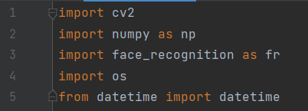

1. ***Cv2* module:** The cv2 module is a part of the Python programming language's OpenCV library ("Open Computer Vision"), which is a collection of tools for working with visual data. OpenCV is a popular library to read and write image files, access the camera on your computer or mobile device, or perform image processing operations.
2. ***NumPy* module:** NumPy is a library for the Python programming language, and it’s specifically designed to help you work with data. With NumPy, you can easily create arrays, which is a data structure that allows you to store multiple values in a single variable. NumPy also includes several functions that make it easy to perform mathematical operations on arrays.
3. ***face recognition* module:** Recognize and manipulate faces from Python or from the command line with the world’s simplest face recognition library. Built using dlib state-of-the-art face recognition built with deep learning. The model has an accuracy of 99.38% on the Labeled Faces.
4. ***os* module:** The OS module in Python provides functions for interacting with the operating system. This module provides a portable way of using operating system-dependent functionality. The *os* and *os. path* modules include many functions to interact with the file system.
5. ***datetime* module:** Python Datetime module supplies classes to work with date and time. These classes provide several functions to deal with dates, times, and time intervals.

* **IDE used-** *PyCharm* (Community edition Version 2022.3)

PyCharm is an integrated development environment used for programming in Python.It provides code analysis, a graphical debugger, an integrated unit tester, integration with version control system and supports web development tools. PyCharm is developed by JetBrains.

**Chapter 2**

**Literature Survey**

A literature survey is a critical summary of what has been published on a topic by accredited researchers. It is a way to get a broad overview of the state of the art in a particular field and to identify key issues, trends, and gaps in the research. In this case, a literature survey for face recognition using OpenCV would involve reviewing the existing research on facial recognition systems in general.

Some key milestones in the history and development of facial recognition technology include:

**1964:** Woodrow Wilson Bledsoe develops the first automated facial recognition system, which used a mathematical algorithm to compare facial features.

**2002:** The United States Department of Defense develops the "Eigenface" algorithm, which is one of the first feature-based facial recognition algorithms.

**2006:** The "Viola-Jones" object detection framework is introduced, which significantly improves the speed and accuracy of facial recognition systems.

**2010:** Apple releases the iPhone 4, which includes a facial recognition feature called "FaceTime".

**2016:** Google releases the Pixel phone, which includes a facial recognition feature called "Trusted Face".

**2018:** The European Union's General Data Protection Regulation (GDPR) comes into effect, which includes provisions related to the use of facial recognition technology.

**Existing research on Facial Recognition Systems**

There has been a significant amount of research on facial recognition systems in recent years, covering a wide range of topics such as the development of new algorithms and techniques, the evaluation of the performance of different systems, and the ethical and privacy implications of using facial recognition technology.

Some key areas of research in the field of facial recognition include:

1. **Algorithm development:** Researchers have developed a wide range of algorithms and techniques for facial recognition, including feature-based approaches (such as eigenfaces and fisher faces), deep learning-based approaches (such as convolutional neural networks), and hybrid approaches that combine multiple methods.
2. **Performance evaluation:** Researchers have evaluated the performance of different facial recognition systems in terms of accuracy, speed, and robustness to various factors such as lighting, pose, and facial expression. They have also compared the performance of different algorithms and techniques.
3. **Applications:** Facial recognition technology has a wide range of potential applications, including security, social media, healthcare, and entertainment. Researchers have studied the use of facial recognition in these and other areas and have evaluated the benefits and challenges of using the technology in different contexts.
4. **Ethical and privacy issues:** As facial recognition technology becomes more prevalent, there have been increasing concerns about the potential for abuse and misuse. Researchers have studied the ethical and privacy implications of using facial recognition technology and have proposed various measures to address these concerns.

**Chapter 3**

**Methodology**

This project mainly focuses on practical implementation of face recognition technology to track attendance and store the names and the time of presence in front of the webcam of a specific face and detects it based on the images stored in a database folder along with the names of the persons whose image is present in the folder.

It then stores name and time in a csv file and then creates an excel sheet to store the attendance records of the faces it detected in front of the web cam. The main library used in the project is OpenCV.

**About OpenCV:**

The concept of OpenCV was put forth by Gary Bradski which had the ability to perform on multi-level framework. OpenCV has several significant abilities as well as utilities which appears from the outset. The OpenCV helps in recognizing the frontal face of the person and creates XML documents for several areas such as the parts of the body.

The minimum requirements for the software would be python along with OpenCV and the required dataset. The minimum requirements for the hardware would be intel i3 or any processor above it and 4 core CPU. Operating systems of windows 10 will be sufficient and 8GB RAM required.

**Brief understanding of the Code:**

**Data collection:**

The project uses a set of images which it matches with the image it sees on the web camera at runtime. It matches the web cam image with each image in the dataset folder by iterating through the folder. The dataset of images which I have used in the code is not a pre-existing dataset anywhere on the internet and is created using my personal images. The program is flexible of detecting new and as many faces if the image of the face to be detected is available in the image database folder.

**Pre-Processing:**

def findImageEncodings(images):

The images in the database are being encoded into a set of eigen values which exist for each image in the folder and then these eigen values are used to generate the distances in of each image in the database to the image it sees on the webcam and then returns the result as the image which has the least matching distance.

The findImageEncodings() function does the work of image encoding using the *face_recognition* module and takes input parameter which is the list of images in the folder.

This function returns a list of image encodings called encodeList[].

def trackAttendance(name):

The other main user-defined function used in the program is the trackAttendance() function which exactly marks the attendance in the csv file along with the time it takes while detecting a particular face on the webcam.

This function uses a csv file which is opened in read only mode initially and then reads the csv file for previous entries of the name of the person whose face has been detected by the cam.

If the entry doesn’t exist, it then writes the name and the current time on the csv file separated by a comma.

In short, deep learning in face detection and recognition broadly works on two areas the first one being accepting the solidary input image or any other relevant picture and the second being giving the best outputs or the results of the image of the picture. I have used dlib facial recognition framework that would be the easy way to organize the face evaluation. The two main significant libraries used in the system are dlib and face_recognition.

**Chapter 4**

**Result and Discussion**

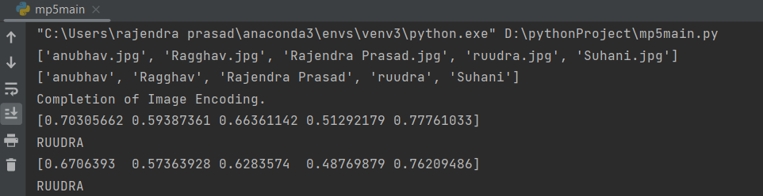

In the above output terminal, the first line of output is the names of all detected images in the dataset folder in a list. The next line of output is the same list as the image names, but it is in the appended format.

The line which says, “Completion of Image Encoding.” marks the completion of the function findImageEncodings() and all images have now been encoded.

Then as soon as my face appears on the web cam, the system calculates the eigen value distances of each image present in the database with my face that it detects on the webcam.

And then writes my name and the time of appearance in the csv file named “markAttendance.csv” that I have imported in the program as seen in the following image.

**FINAL OUTPUT OF THE PROGRAM**

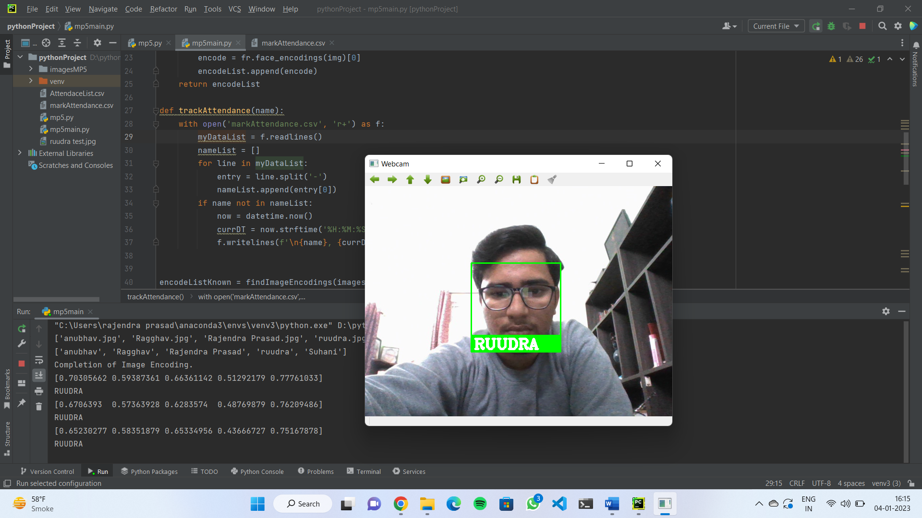

This is the main output screen after the detection of the face**.** The above image of the whole screen shows the detection of the face along with a rectangle around my face and label of the name it has detected from the list of names extracted from the image database folder.

**Chapter 5**

**Conclusion and Future Work**

Face recognition systems are currently associated with many top technological companies and industries making the work of face recognition easier. The use of python programming and OpenCV makes it an easier and handy tool or system which can be made by anyone according to their requirement. The proposed system discussed in this project will be helpful for many as it is user friendly and cost-efficient system. Hence using python and OpenCV the face recognition system can be designed for various purposes.

**Advantages:**

The advantages of the face recognition system include faster processing, automation of the identity, breach of privacy, massive data storage, best results, enhanced security, real time face recognition of students in schools and colleges, employees at corporate offices, smartphone unlock and many more in day-to-day life.

**Disadvantages:**

Few disadvantages in this system include the costing, or the funding, very good cameras of high definition are required, poor image quality may limit the effectiveness of this system, size of the image will matter because it becomes difficult to recognize the face in small images. Face angles can limit the face recognition reliability, massive storage is required for this system to work effectively.

**THANK YOU!**